A Tribute To Charles Butts, OD, Dean Emeritus CSO,
1924-2014
By Ray Gottlieb, OD, PhD, Dean CSO and Sarah Cobb

“We were ashes until Charlie came along.”
J. O. Jenkins, O.D., Past President CSO

Charles Butts the Man
Charlie was born in June of 1924 in Missouri where lived most of his life in. In WWII he became an army pilot, flying the "Hump," a 530-mile long passage over the Himalayan Mountains in the China-Burma-India Theater. This dangerous task took a heavy toll as nearly 1,000 men and 600 planes were lost over the hump by the end of operations in 1945. Soon after returning to Missouri he married Rosemary, and they began a 68-year marriage made in heaven. In 1950 they moved to Chicago and lived in a trailer while Charlie attended the Chicago College of Optometry.

Rosemary describes Charles’ early years in syntonics: Dr. Cecil Henry, a classmate and friend at Chicago School of Optometry, bought a practice in Kansas City from an optometrist who used “some sort of light” therapy that Dr. Henry continued to use with great success. Several years later Charlie heard about another optometrist, Dr. Herman Haganah, who also used light and practiced nearby. Charlie contacted him and soon was making weekly trips to learn more syntonics. In 1964 he heard about a syntonic convention near where they lived and Charlie and Rosemary went to the banquet. There were about ten O.D.’s attending, including a new member, Dr. Lowell Becraft. J. O. Jenkins was also there. The banquet entertainment was everyone getting up to tell jokes.
Charles was “on fire” after that, according to Rosemary and she joked that Spitler’s Syntonic Principle was Charlie’s ‘mistress’ because he came to bed with ‘that book’ every night. Dr. Spitler who was the founder of syntonics had passed away om 1961 but syntonics was still being taught on Spitler’s model. Charlie decided that CSO would attract and retain more new members if the basic course was simpler and more optometric. So he developed a new Basic Course. He became director of education, then eventually CSO Dean, and began teaching it in his new way. (More about this later.) Syntonics became central to his approach and in the mid 1980’s when he sold his practice and retired for health reasons he kept the records of more than 3,500 successful syntonics cases.
He practiced optometry for more than three decades in California, MO and was successful enough to become part owner of a bowling alley, a nursing home, and a milk delivery business. Always up for an adventure, he owned his own airplane that he flew for vacations and to attend conventions, and when he sold his airplane, he bought a motor home that he and Rosemary drove to vacation as far away as Alaska and southern Mexico.

For the last 20 years, Charlie and Rosemary lived in Missouri in the warm months and in Mission, Texas for the rest of the year. He was still very involved with syntonics and enjoyed being go-to guy for new as well as experienced syntonists. Right up to the last, “Charles still got calls – ‘Picking my brains,’ he said, ‘Why don’t they study the book?’”
Charles is survived by: Rosemary, 3 children, 13 grandchildren, 20 great grandchildren, hundreds of friends and colleagues, and his long time and beloved “mistress”, The Syntonic Principle. A grand celebration of his life will be held in Missouri in June, 2014.

The Charles Butts Legacy
Charlie preserved our History
Dr. Gottlieb: Charlie was the last syntonist of his generation to pass away. He was there in the mid-1960’s when CSO and syntonics faced a major crisis. Charlie made sure to leave us bits and pieces of writing about that difficult period. The rest of us, the “new old generation” didn’t come along until 1975.
We will attempt to review some of the history of what happened next. In preparing this tribute article I discovered a 250-page Butts file hidden on a dark, dusty place on my hard drive – CharlieAdvCollection.pdf. It’s part of his legacy along with great write-ups of how to do syntonic fields, pupil assessment, string test, etc. (that are in the “Blue Book”). He also included letters he wrote that explain his thinking in designing the basic course, and how he arrived at some of his strong opinions. In addition are a selection of writings by Spitler and other syntonists. This file is the basis of my descriptions below. He gathered these writings in a 248 page three ring binder that he gave to Sarah Cobb. Sarah’s husband, Jim Patton, scanned the pages as a pdf file and gave me a copy. Some of what follows is quoted directly in Charlie’s words to convey something of his personality.
Charlie wrote to Sarah:
Dr. Butts: “This book (CharlieAdvCollection.pdf) is only a very small amount of the material that I wanted to include. The articles written by Syntonic Optometrists back in the 1930's and 1940's show that it wasn't described in optometric terms. If so, it might have been more accepted at that time. The Syntonists in that period had to defend their position of semi-medical practice. If they had initially put it in optometric terms and procedures syntonics would have gone over. So much for the hindsight. We today are optometrists and aren't interested in practicing MEDICINE but only interested in helping people’s visual problems regardless of what has caused the malfunction. Our problem is we have to study the medical model to understand Syntonics. Some of these articles here are very good reading. They show the power we have in Syntonics. Use it for Optometry.”
Charlie becomes a syntonist
H. Riley Spitler, DOS, MD, PhD, MS, FSCO
— 1899-1961 —
Formerly Clinician McFadden Sanatorium, Battle Greek, Mich.; Physician-in-charge Crab Orchard Sanatorium, Crab Orchard, Ky.; Past President State Board of Optometry, Ohio; Past First Vice-President American Optometric Association; Accredited teacher of Mechanotherapy and physical therapies since 1925 by Ohio State Medical Board; Past Dean Department of Mechanotherapy Metropolitan College; Dean Central States College of Physiatrics; Fellow American Academy of Optometry; Founder and Dean College of Syntonic Optometry.
Spitler circa 1924. Note the right exotropia.
Dr. Butts: “It was very strange how I got into syntonics. I had a patient that I had sent to every Ophthalmologist to try to get help and we could not get her any help. Dr. Cecil Henry bought Dr. I. Plam's practice in K.C., MO. Plam was a syntonist and sold his equipment to Cecil who had a medical background and understood light. He was using Spitler’s filters with a Carbon Arc for the light source. It worked well but you had to use carbon that contained certain minerals to get the proper affect with the filters. Anyway I called Cecil and asked if he could do this patient and explained her problem. He said he would try. I said she couldn't pay. He said O.K., but she would have to stay at a hotel. I said she couldn't afford it. His answer: "Why in the HELL don't you take the course and help her?"
“WELL, that is the Start of my experience: Taking a women going blind starting with V.A. 20/300 in each eye and bringing it back to 20/40 in 15 treatments. I cried. I couldn't believe what took place in such a short time. I had brought one instrument at the basic but in three weeks I had to order another one and then another one. I had three working most of the time. When you get into this work your patients bring others and build your practice. Before I retired due to health (I was diagnosed with 4 aneurysms and thought I didn't have long to live) I was doing an average of 23 patients a day over a year’s time.”
The history of why we changed from the original syntonizer
Dr. Butts: “In the 1930’s the FDA filed suit against Dinshah Ghadiali who faced a series of court actions as the government moved against his healing practices. Dinshah used light on the body over the organ that needed treatment. He had a large following and some of his people ran ads in the Chicago Tribune claiming that light would save their life. He was arrested for fraud in 1931 but was acquitted. In 1945 the government acted again. Ghadiali faced charges that he had made false claims about his spectro-chrome healing device. In 1947 he was convicted but not sent to prison on the condition that he cease practicing chromotherapy. His books and unsold devices were destroyed, and those that had been sold were confiscated from their owners. The day before he went to court, his building holding all of his records mysteriously burnt to the ground. This news ran rapidly through all light therapists and all went underground.”

Dr. Butts: “Dr. Spitler unexpectedly died of food poisoning in 1961. Many of the original members were retiring and the FDA was still putting pressure to purge non-mainstream medical approaches. In the early-1960’s the FDA sued CSO. It went to court in Omaha NE. J.O. Jenkins was CSO president at that time and attempted to defend the college. We lost the suit and the right to practice syntonics. As a consequence, many CSO members stopped doing syntonic treatments, afraid that their state optometry boards might take away their licenses. Some of the old guard who went on practicing syntonics [Thank Goodness] but not talking about what it would do. CSO membership dwindled.” No one wanted to take responsibility for the college. In 1964 we knew of only five men practicing syntonics.”
“After Dr. Spitler had passed away, the physical college building in Eaton, Ohio was sold and the money given to Spitler's widow. We had to remove the college belongings from the building. The books, materials, instruments, etc. were bundled up and sent by truck to J.O. in North Platte, NE. Unfortunately we shipped them across the state lines without proper labeling. It is a Federal law that all medical instruments have to be labeled when they are sent across state lines. Somehow the feds got wind of it and Federal agents stopped us at the Ohio border and confiscated and destroyed what they found. Fortunately some made it to J.O.’s.”
(Dr. Gottlieb: Rex Cross told me he remembers when FBI agents arrived at J.O. Jenkins’ house with a warrant to search it for syntonic materials. But J.O. was too crafty for them. Mindful of a possible raid, he had carefully and successfully hidden syntonizers and their manufacturing molds in his attic.)
Dr. Butts: “In the late 1960’s syntonists wanted stop hiding and practice syntonics out in the open. Three of us met with the FDA federal director for the Midwest in Kansas City, MO: Dr. Herman Hagenah, Dr. Joe Shockey and myself (Charlie Butts). The director told us he had no opinion about whether syntonics worked. But if we wanted to practice legally, we would have to change the syntonizer because it was considered a medical device. If we removed the colored filters, it would not be considered a medical device and so could be legally shipped across state lines. “
“We worked through several stages of redesigning the syntonizer and finally came up with the present model. We took the three disks that held the filters out of the old instrument, mounted them individually in their own holders and packaged them separate from the syntonizer. J.O. paid out of his pocket for as many of the old instruments we could find and rebuilt them into the present instrument. When our supply ran out, J.O. started manufacturing new ones in the form that they are manufactured today.” (Currently this instrument –“The College Instrument”– is manufactured, sold and distributed by Rex Cross. RG)

Charlie redesigns syntonic treatment and the Basic Course
Dr. Gottlieb: I remember being confused about how exactly to use various charts that were in our handouts when I took the Basic Course. These seemed disconnected from what Charlie taught us. As I read the papers in the CharlieAdvCollection.pdf file and learned what Spitler taught his basic, I understood how these charts were used. In 1967, after Charlie had been using syntonics in his office so successfully for several years, clear-headed and passionate about saving syntonics, Charlie took on the challenge to save CSO and syntonics. Passionate is the perfect word. Until the day he died he thought a lot about what more he could contribute to CSO.

Dr. Butts: “When I took the basic course we learned to treat symptoms. This was the medical model of syntonics that was taught by Spitler, who was trained as a medical doctor before he became an optometrist. Although Spitler taught about the OEP 21-points and visual fields he rarely referred to them after that. Optometric measures were not really part of the syntonic diagnosis or treatment. We took a history, recorded the symptoms and treated the patient with light until their symptoms went away. Some needed only a few treatments. If later the symptoms returned, the patient came back for more syntonics.
This is Charlie’s description of Spitler’s syntonic procedure:
- Take optometric measures: acuities, binocular balances, refractive state, pathology, & visual field
- Record a detailed medical history and list of symptoms.
- Refer patients for medical attention if a serious medical condition or one that would prevent successful syntonic treatment (e.g. dental infection) is indicated.
- Compare the patient’s symptoms with the sympathetic vs. parasympathetic and the affected glands chart showing over-activity symptoms.
- Compare with the asthenic and piknic symptom chart of behaviors and conditions typical for each type.
- Go to the syntonic balance board chart to select the filter based on the information we have so far.
- Compare filter choice it with the filter actions chart to see if it fits the needs.
- Then give syntonic treatment with the selected filter until the symptom went away.
Dr. Butts: “I was appointed Educational Director in 1967. By then I was doing over 20 therapy patients a day and having fantastic success. I had memorized Spitler's book and went back into my physiology books and studied like mad. We had quite a few men still in the college but most were retired and others were laying low due to the FDA harassment. They all knew the value of Syntonic therapy and were very sharp and knowledgeable in the treatment phases, BUT they were retiring and new Optometrists were not coming in to take their place. “

“I tried to teach the syntonic model as it had been taught to me by the college course, but the information and procedures were difficult to implement because it was oriented toward a medical rather than an optometric model. This scared the incoming optometrists to death because the state boards were on guard about optometrists practicing medicine and they looked DOWN on anything they thought was quackery. Licenses could be taken away for such practices. I could see that teaching syntonics as a medical procedure was not the way to go. I felt that something had to be done to save this wonderful therapy.”
“I was an OEP-trained Optometrist and was using the testing and training methods as they were taught then. If we wanted to continue this therapy it had to be taught in Optometric terms -- AS an OPTOMETRIC technique.“
“All of the Basic I stole from other people. I'M THE FIRST TO SAY THIS. I had learned a lot from Dr. Henry and Dr. Haganah and had studied the books by the other light practitioners. I just tried to put it together for OPTOMETRY. So this is why I say study SPITLER he is the grandfather of it all.” (Dr. Gottlieb: If you read Dinshah, Loeb and Henning you will see that he got some of his ideas and terminology from them, – e.g. the terminology of mu/upsilon as the ‘Acute’ and mu/delta the ‘Chronic’ filter is taken directly from Dinshah and not Spitler.)
“In my new Basic Course I taught what worked for me in my practice. In great detail I drilled the students on how to measure and record functional visual fields, diagnostic procedures using the string, the 21-points, alpha-omega pupil testing, medical history and visual complaints and symptoms. If you do these it can never be said you are not practicing Optometry. They provide an optometric measure of where you started pre-treatment and what you have accomplished during and post-treatment.”
Charlie put together a basic cookbook of treatment protocols – These included:
- The five syntonic syndromes and the filter combinations used to treat them.
- What each filter combination does,
- How to determine and write syntonic prescriptions,
- How to set patients up in the syntonizer with the main filter closest to the patient and the augmenting filter closest to the light source,
- How to begin treatments by nascentizing for three minutes,
- That treatments using one, two or sometimes three filter combinations, are given for a total of 20 minutes.
- Flash the light to increase the power of the treatment.
- That treatment sessions must occur daily for at least three days in a row each week with a rest period of a few days between,
- The number of treatments in a complete series of sessions is 18,
- Check progress after 6-8 treatments to evaluate if the filters are correct,
- How to when and which filters to change to if necessary,
- When to take post-treatment measures and
- How to know whether and when to start a second series of treatments, if needed.
“I also taught about where to purchase the equipment and about how to care for the syntonizer – the vibration type of 50W light bulb, the voltage transformer, number of hours before light bulb needs to be replaced by a new bulb (the bulb darkens after about 20 hours and needs to be replaced, and how to clean the instrument and filters. (These maintenance procedures are often overlooked but, ignore them and your rate of success goes down.)”
“The treatment goal was to correct the underlying causes of poor fusion, tropia, accommodation, versions, amblyopia, asthenopia, all the optometric symptoms that I could think up. I designed a new patient receipt form to give to the patient after the visual/syntonic evaluation that that included a list “optometric” visual symptoms with the appropriate ones checked off for that specific patient, as well as the cost, and lens Rx.“
“I tried to: “Keep it Simple Stupid”. That was my saying to myself from then on. Using this simple approach, one can be a very successful optometric syntonist and never learn the medical model. The “Miracle Workers” of optometry correct 80% of all visual complaints. Can't, beat that. Optometry bought it. You can see how far we’ve come since that time.”
“How did I arrive at 20 mintues and 20 treatments and the sequences of not less than 3 per week? I discovered by using this sequence I could correct 80% of complaints and not have them to reoccur. This was an excellent percentage. Less than three treatments per week was a waste of time as we could not get the results we expected. We found 10% had to require more than one sequence of treatments. Usually trauma involved. The visual fields told this to us.” [Read the article in your blue book.}
“Dr. Henry found taking two or three days off between treatments helped the body to retain and maintain the therapeutic changes at the highest level of success. I was verifying this also in my practice. Then after the final therapy session it takes the body about 7 days to come into its own balance. Waiting seven days to take the field after the last therapy gives us a more accurate measure of lasting success.

Charlie brings functional visual fields into syntonic treatment protocol
WHY I INCORPORATED VISUAL FIELDS INTO SYNTONIC OPTOMETRY
From a paper by Charlie Butts written around 1966
“Dr. Cecil Henry of Kansas City, MO exposed me to Visual fields and their value. I have been practicing the wonderful world of Syntonic optometry for almost eighteen months. This paper is based on what I learned and I hope it will especially help new to syntonics or those who’ve been doing it for just a short while.”
“A visual field study is one of your most important tests that can be run in Syntonics. It shows the patient his condition that he himself can see. He told you where to put the white dot, green dot, red dot, and blue dot. He told you where the areas of his loss are. What could be more dramatic to him in actually seeing a part of his eye not working correctly?”
“After Syntonics is completed I always wait a week before running his final exam and field study. As you men that run field studies know, this is a long awaited, anxious time for the patient who is worried, wants to know and is usually astounded at the results. All of the dim areas of the field have cleared. He can see his improvement.”
“If this patient had been given syntonics without a visual field study and the initial acuity measured a 20/25-20/40 loss in V.A., he would say you didn't help me at all and this syntonics is a lot of nonsense. All you can do is to stutter and say we did have this and this improvement, but you can't prove it to him. Fields prove this to him and you have a permanent record of the retinal area for the future and he is yours forever!”
“How my practice has changed in the last year. In 1965 I ran over 250 fields on syntonic patients. Not only did the patients benefit from this but so did I. I did not run visual fields on all of my patients in 1965 but I'm trying to do better in 1966. In my opinion, the taking of visual fields when practicing Syntonics is absolutely necessary. This gives the beginning syntonist confidence. He can see what he is doing – the patient sees this also. Lately most of my patients have already heard about syntonics from satisfied patients. In fact, every once in a while, I have one come in and says "Doc, I need some of those 'treatments’ (this is always the word they use) that you gave so and so. We check them carefully and completely and usually they do!”

Charlie’s Legacy of Concern
Dr. Gottlieb: Charlie was known as the “Master Syntonist” and the “Father of Modern Syntonic Optometry”. You can see why. Based on his extensive reading and clinical success in his syntonic practice, he had great confidence in syntonics and his approach. He had strong feelings about how things should be done and wasn’t afraid to express them. He wanted syntonics to thrive and was concerned about several items that he felt would hurt syntonics. The following paragraphs were written by Sarah Cobb to make sure that Charlie’s concerns would not be forgotten.
Fundamental Principles – By Sarah Cobb
In all the years I’ve known Dr. Charles Butts and asked him questions, there were certain principles he believed in. Charlie carried on the tradition that came before him, following the protocol set forth from the beginning by the likes of Spitler (The Syntonic Principle,1941), Loeb (Handbook of Specific Light Therapy, 1929), De Jarnette (Chromotherapy,1941), and later optometrist J.O. Jenkins and others. Charlie studied Spitler throughout his lifetime and regularly treated himself with Alpha Omega/ Mu Delta.
In an interview April 2006, he was asked how important the office setting was in providing phototherapy.
“In my opinion the office is the only was to practice syntonics. In fact I can count on one hand where I tried home therapy (they were family, where I could monitor them every day). The reason? You have an idea how the patient is responding... I saw my patients every day, especially children. I asked them questions and touched them to let them know I was there. It is also very important to have a therapist in the room to monitor all patients. I always set appointments so I had between two and three patients at a time.” Of the 3,500 patients that through his office in Missouri, he required that they come in 3-5 times a week for syntonization in his office.
Charlie often commented that optometrists didn’t know how important the light source was that often he would find a syntonizer with the wrong bulb in it. He insisted that it be an incandescent 50 watt, 120 volt bulb supplied by 142 volts from an autotransformer. It was also important that the bulb be a vibration bulb. This set up seems to deliver a higher quality spectrum of light to the patient. He also emphasized use of glass filters because there was a documented history of positive outcomes using established protocols and these instruments.
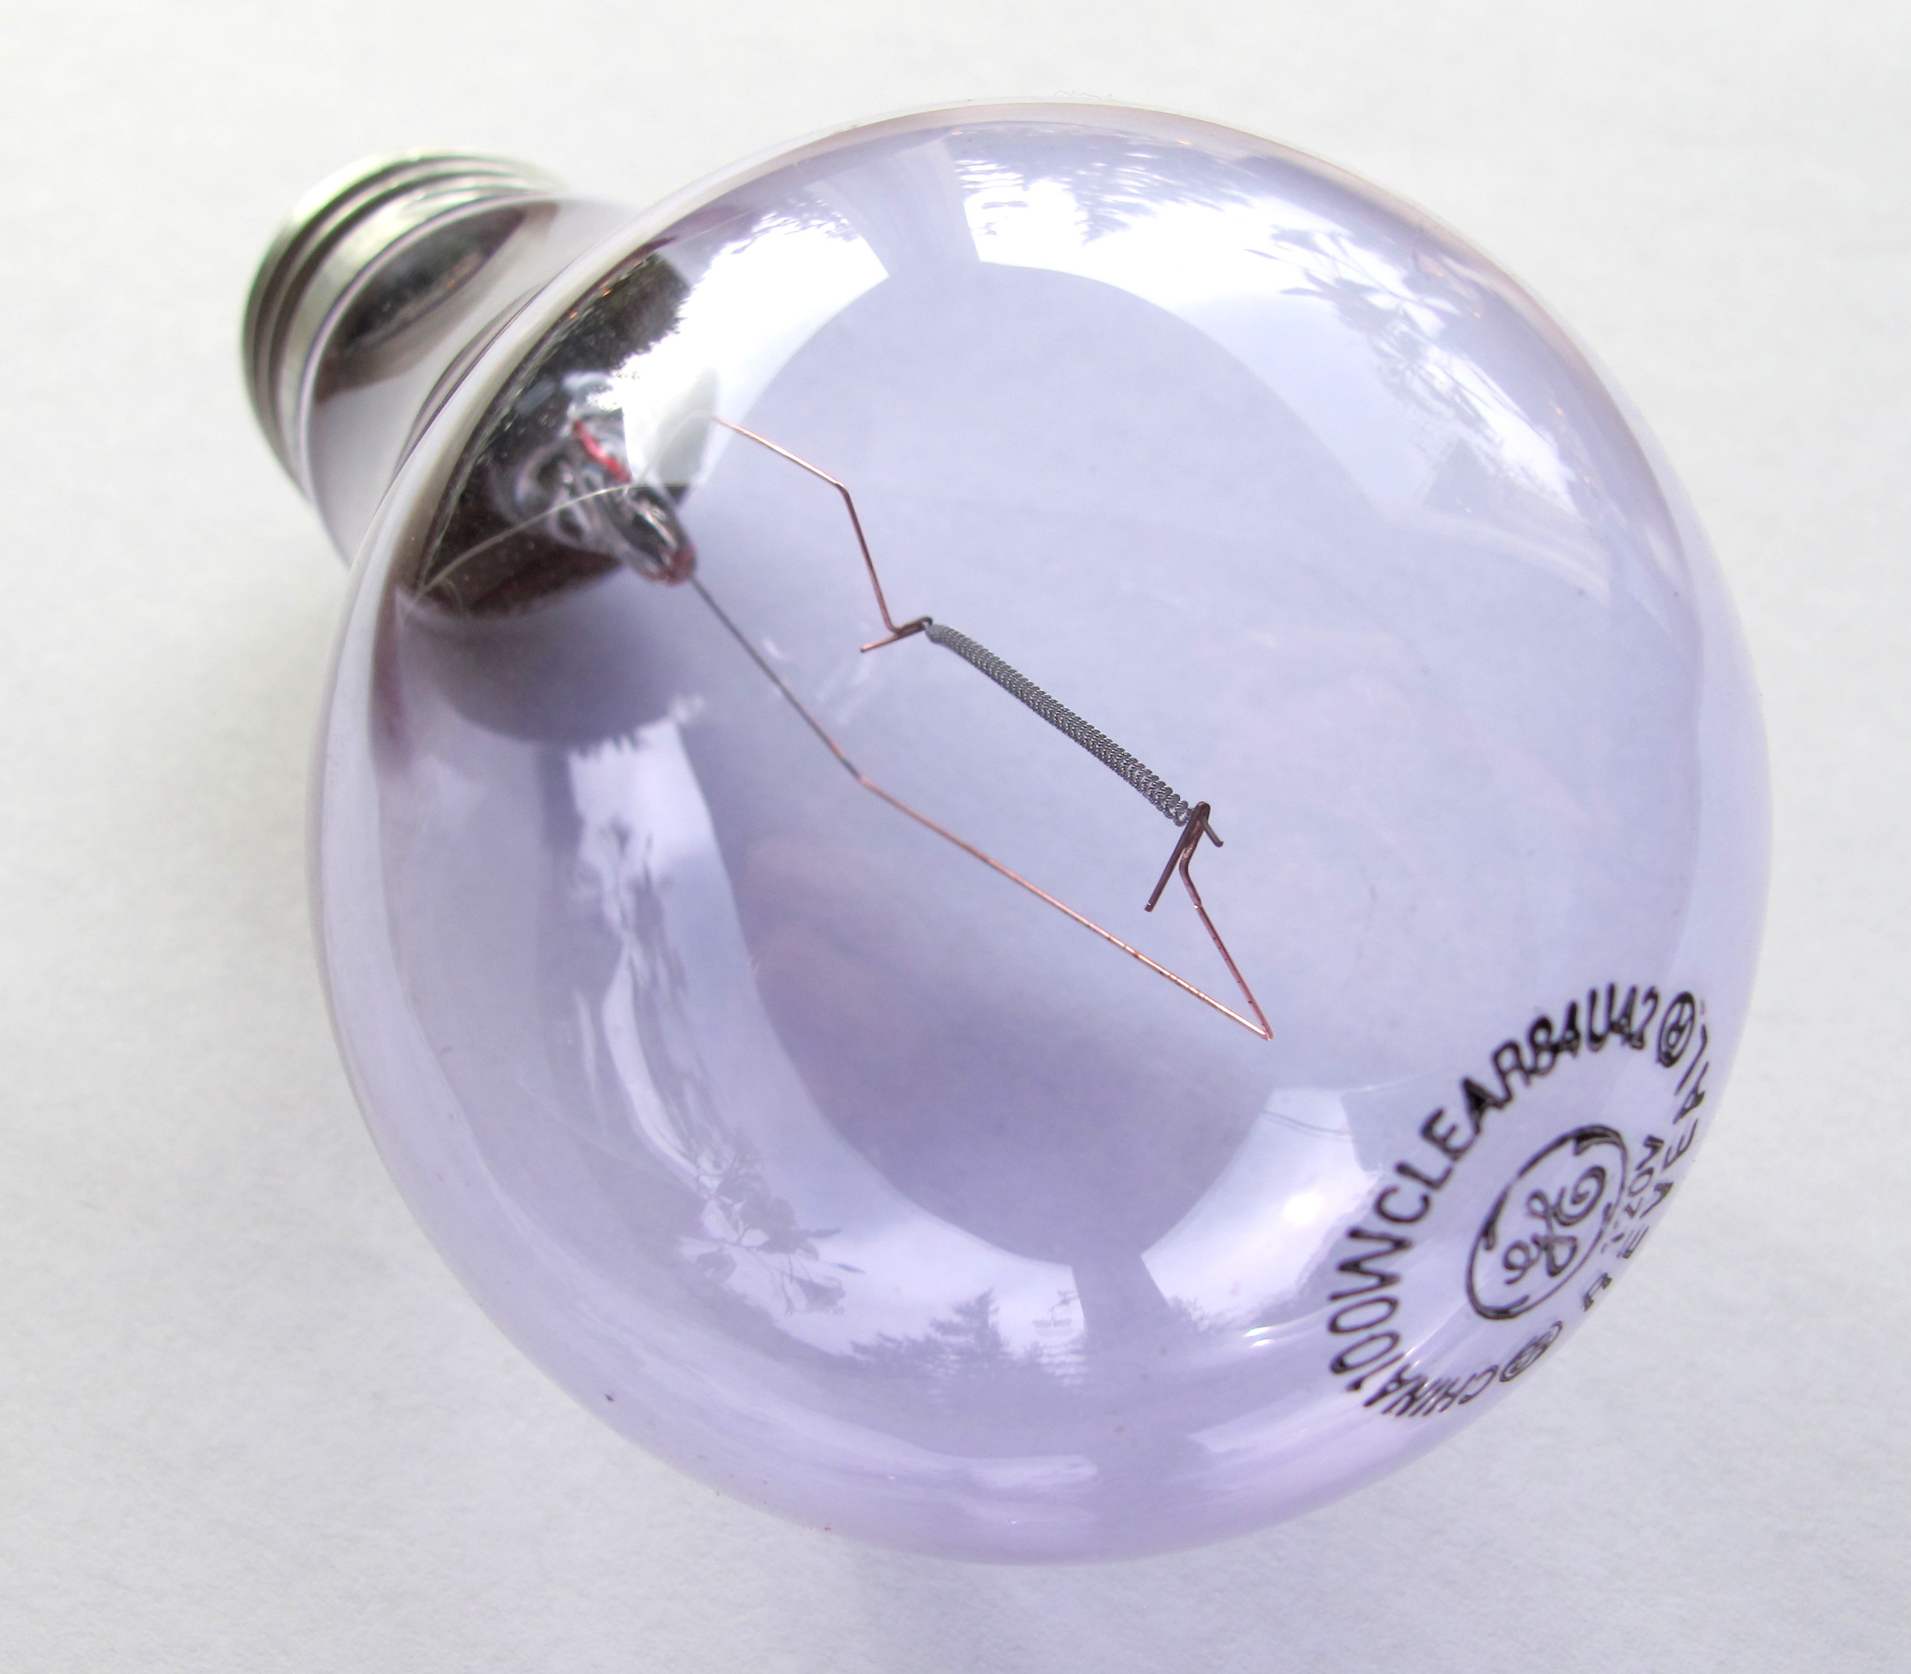
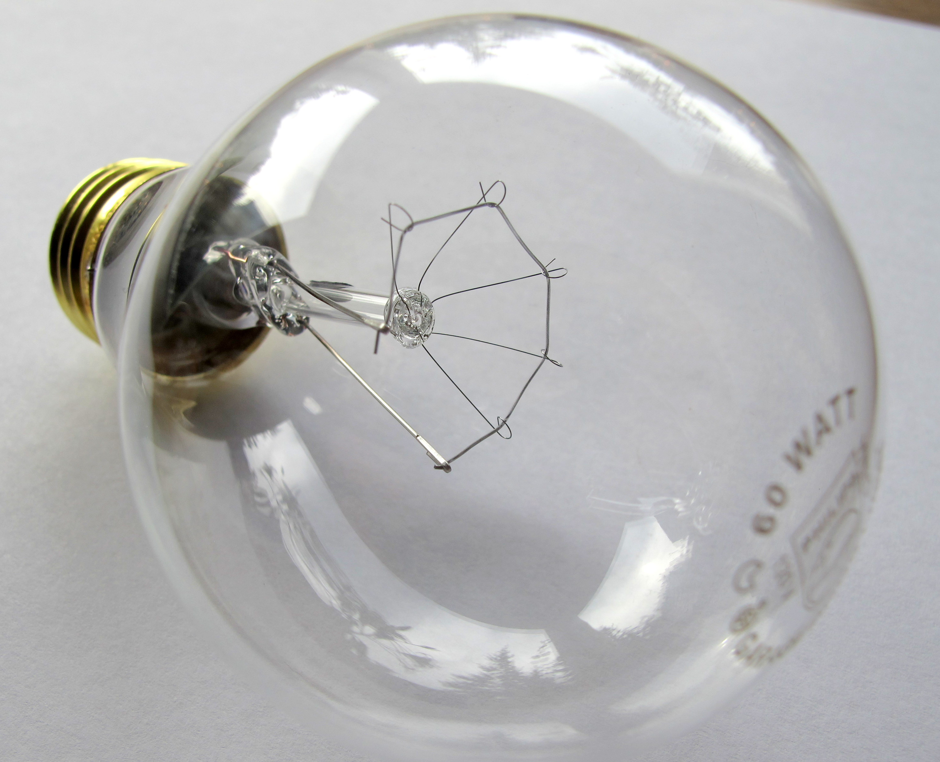

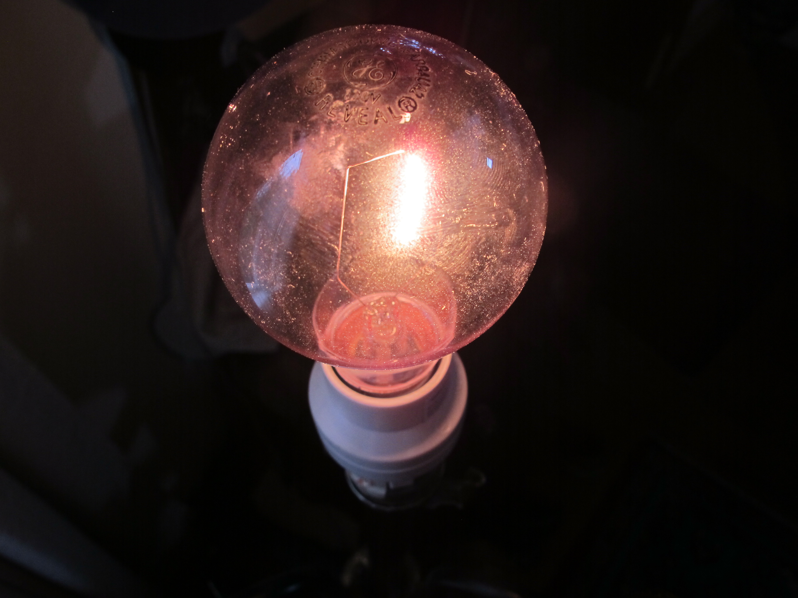
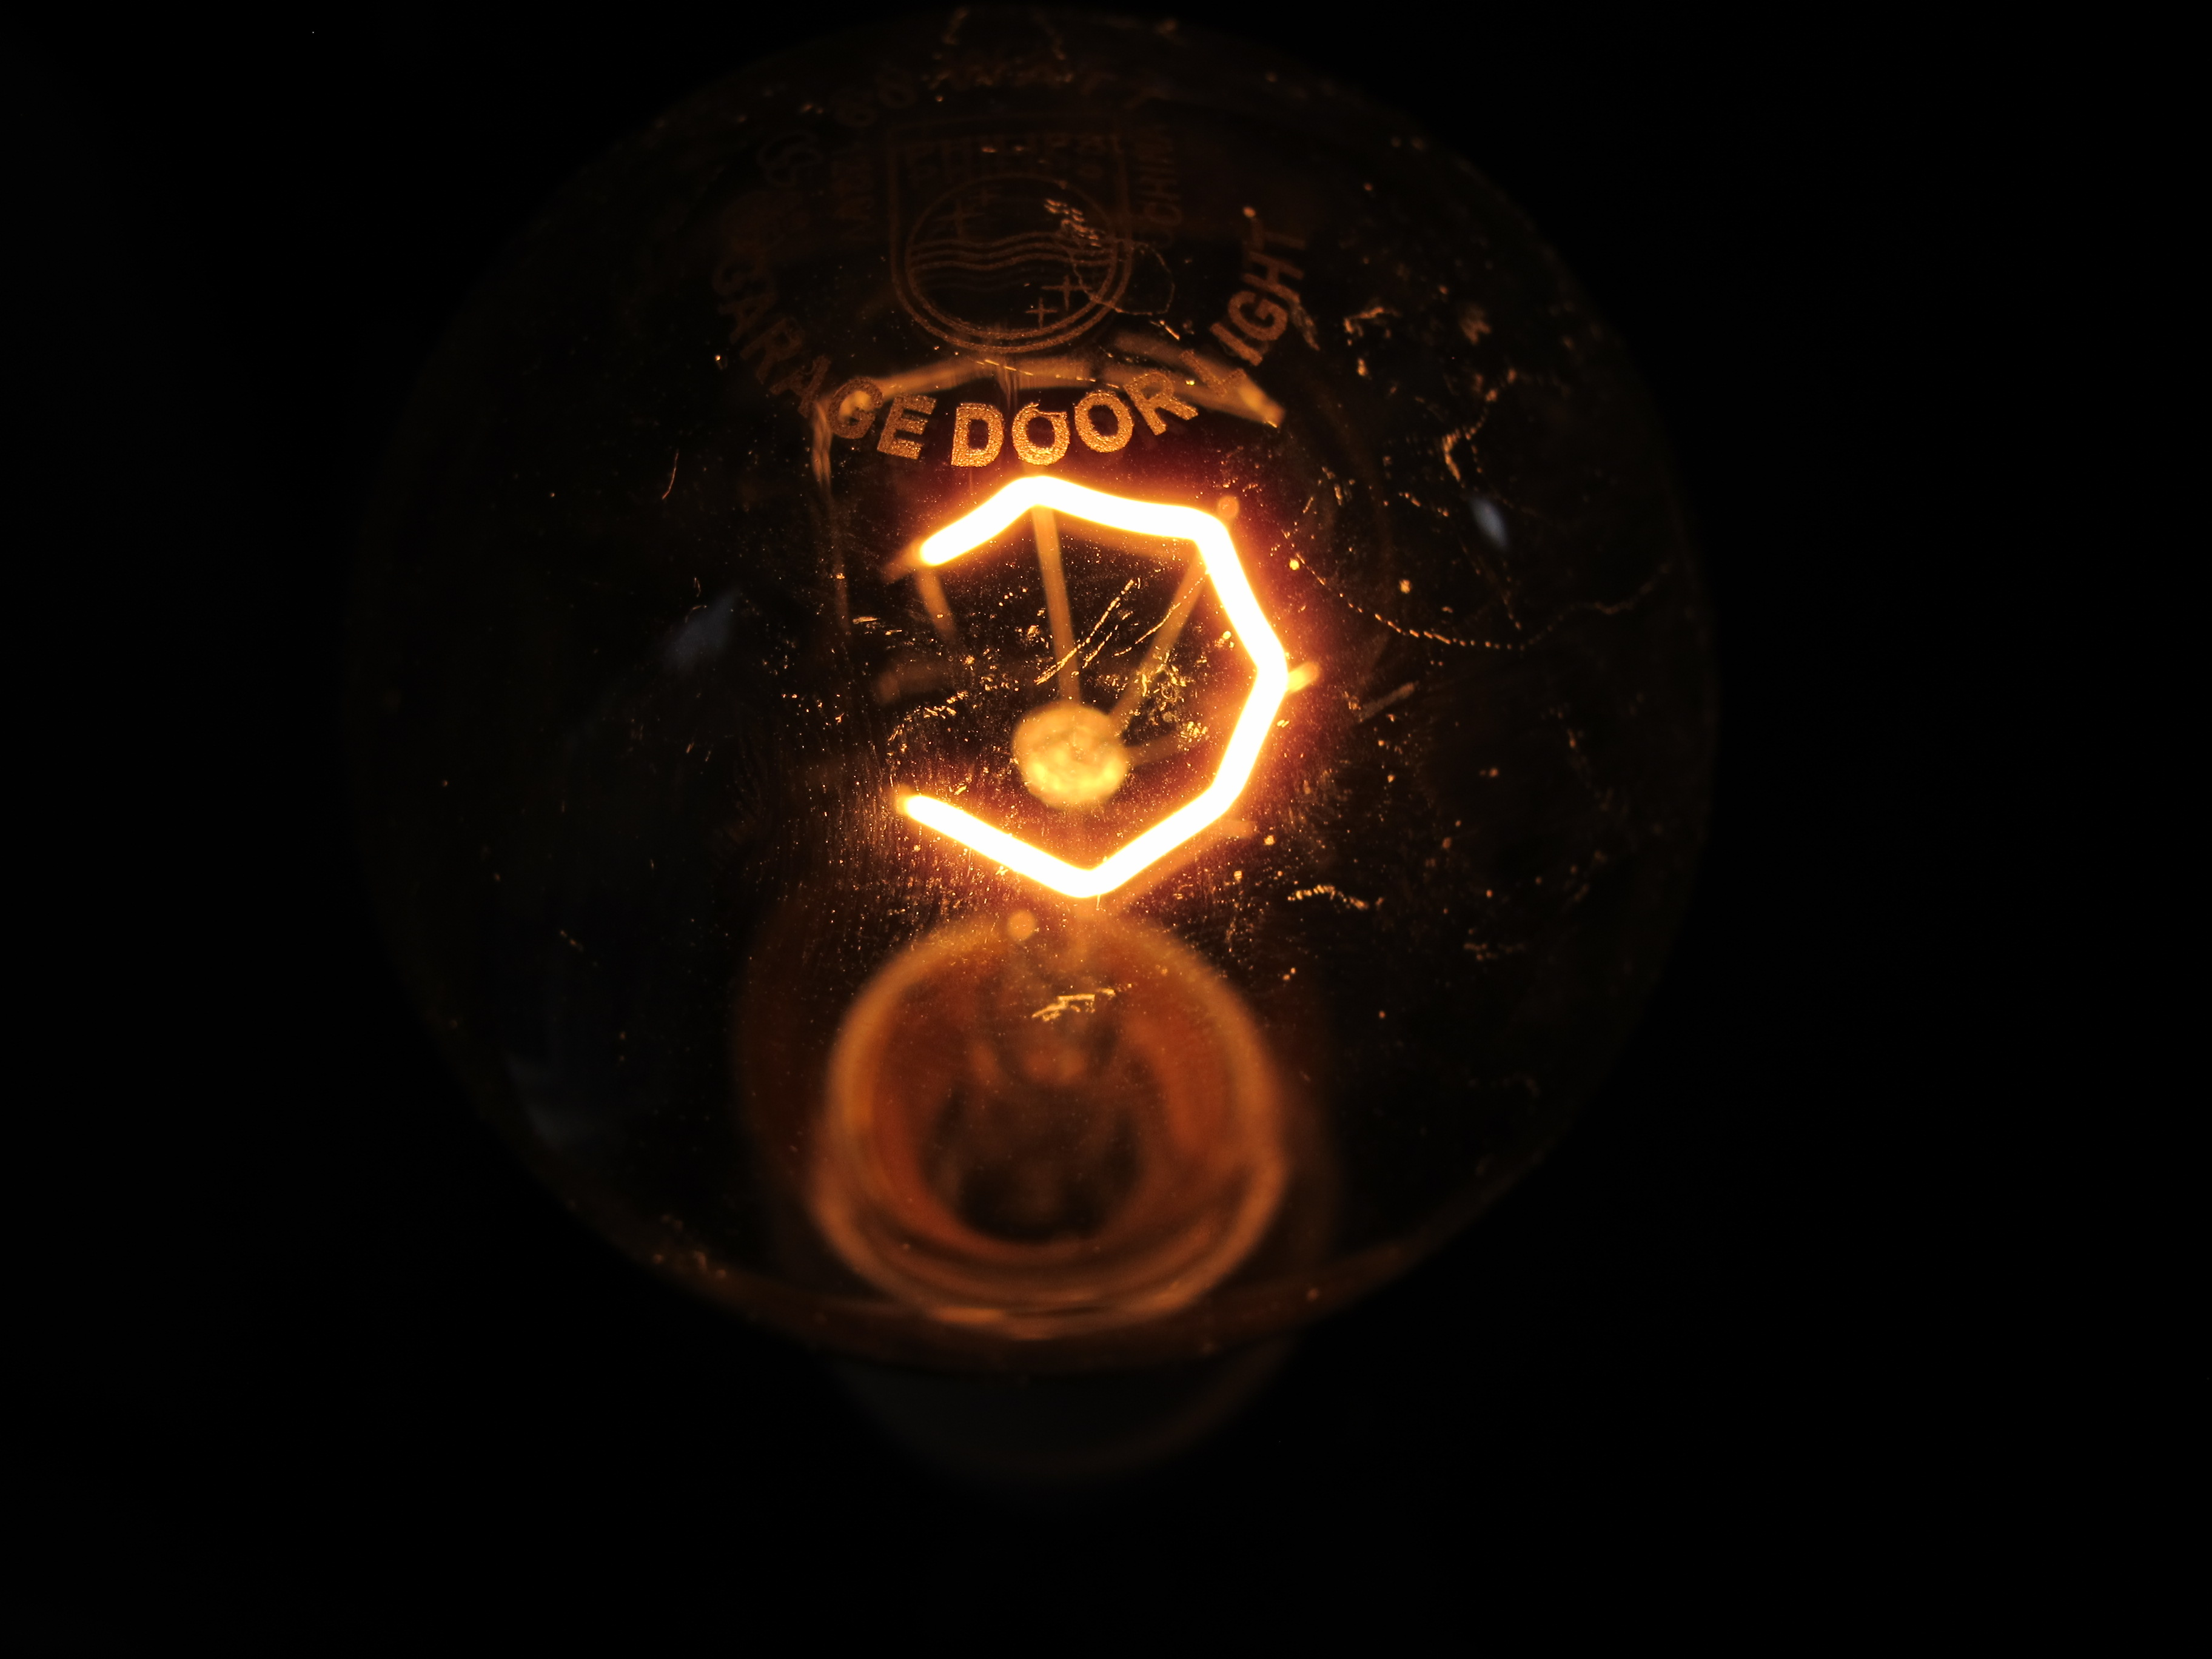

On the left is the vibration bulb. Note the spread of filaments in an arc, giving maximum filament exposure to the eye. The bulb on the right represents a style of incandescent. When this bulb is in the instrument, only the end point of the filament is presented to the eye.

Charlie said that if you wanted to jump-start a case, the patient could take two 20-minute sessions a day, at least 4 hours apart for the first three days. After that he said that 2 sessions a day wouldn’t help. Often, at this point, he would map another field. During syntonization he asked patients to move their eyes around slowly to expose more of the retina.
Charlie often said that syntonics was so powerful in changing and balancing the whole physiological system, not just the eyes, that if optometrists understood this they would study the actions of the filters more, master the fundamentals and be more mindful of the light sources used in instrumentation.
In an interview for the journal dated March, 2009 Charlie was asked how the College of Optometry changed him. “First it changed my life, my being, my practice, and my approach as an optometrist. I’m proud to say Larry and Ray have led us well and the new ones are carrying this forward… God bless the torch carriers.”
Charlie’s Legacy of Love, Generosity and Commitment
Dr. Gottlieb: The lessons learned from Dr. Charles Butts’ fundamental approach to syntonic optometry provide us with lasting illumination and inspiration. He was proud, pleased, grateful and very relieved when he passed the rains to the new leadership in the mid 1980’s. Sarah Cobb was perhaps closest to Charlie and Rosemary during the last decades. As our journal editor and beyond, Sarah interviewed, edited and published a Charlie column for more than a decade. They often spoke by phone and she visited him just a few months ago. It was Sarah that Rosemary called to inform us of Charlie’s passing.
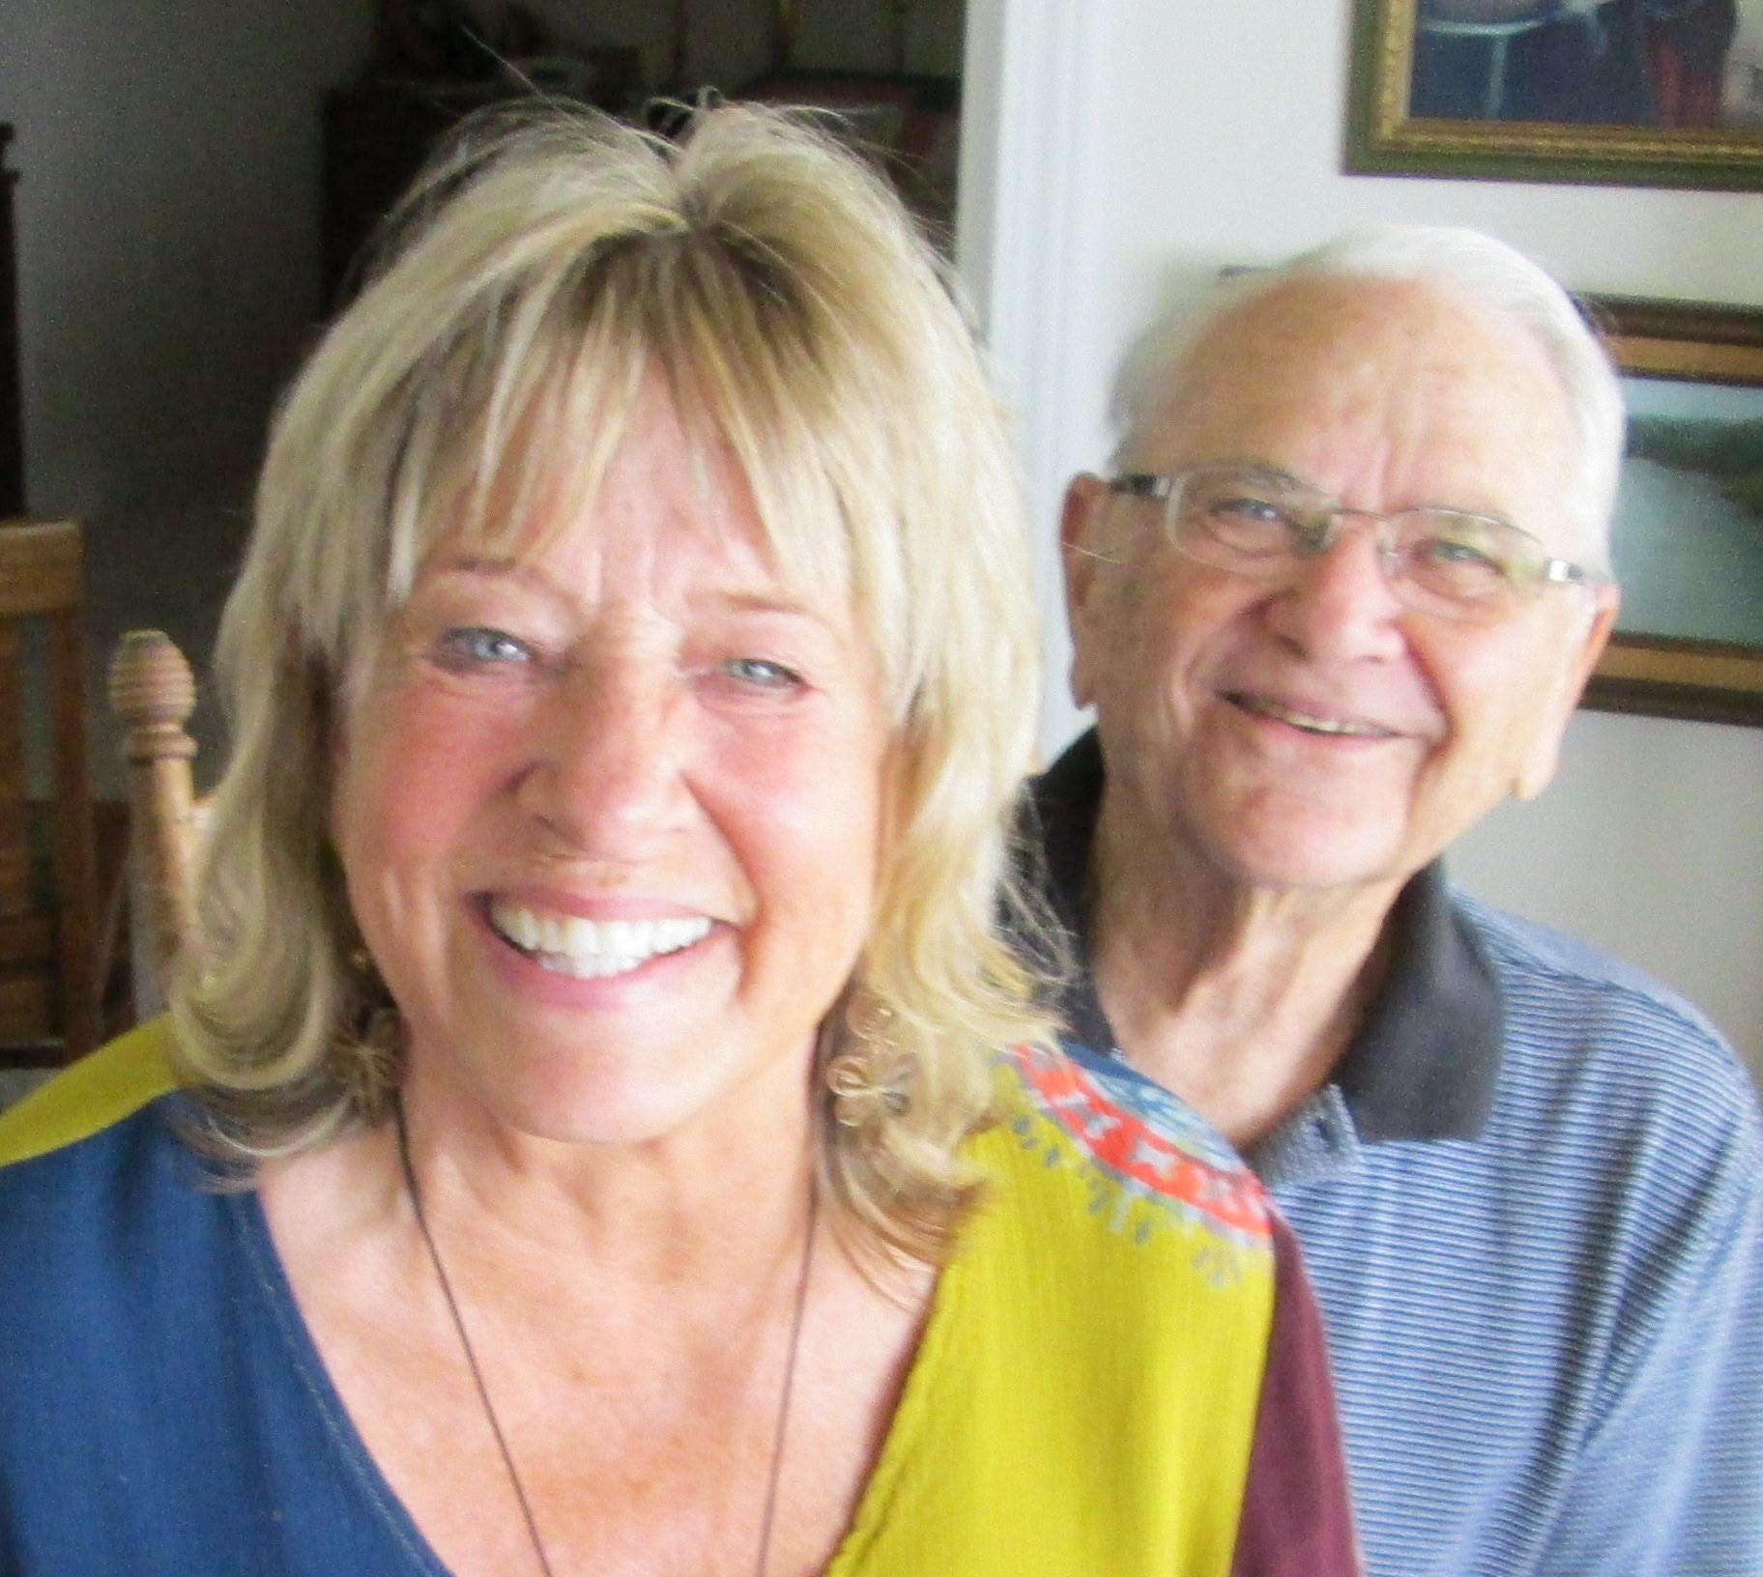
My Last Visit – By Sarah Cobb
My last visit with Charlie and Rosemary Butts was just a few months ago when we took this picture. My husband and I had become friends with them both over two decades ago in Texas, when Charlie came to our house and offered light to my beloved father who had suffered a stroke as well as macular degeneration. On this recent trip we had quite a nice time catching up before Charlie called me out to his office, a lakeside cottage that was on the waters edge.

He asked me if I would map his field. He preferred me to use a small probe and move it slowly. His field was amazing. The color fields were full without interlacing, and his blind spots were normal in size. He asked me to move the probe slowly around the outside of the blind spot to look for areas of compromise. There were none. He remarked that his fields were “Not bad for a man soon to be ninety.”
After that I asked him about ionization, a concept I’ve had trouble understanding. He asked me if I had read page 145 in Spitler. I had read that passage before. Charlie pulled out his book, a hardback that has been tabbed with bookmarks and rebound in cloth several times. He opened it to page 145 and asked me to read the passage to him and we discussed it. Spitler wrote that higher frequencies of light were more capable of ionization of the photochemical substances in the retina than the lower frequencies. Charlie drew my attention to a diagram of a cross section of a cone on page 159. Finally the subject changed to the frequency combinations, Alpha Omega/Mu Delta and the glory of taking Alpha Upsilon.
Charlie has been a light in my heart, but also light to guide my path. Not only did he save syntonics for future generations through his teaching and leadership, but he saved my father’s sight, reading, and enjoyment. He will be forever missed.
Charlie’s Clinical Records Legacy
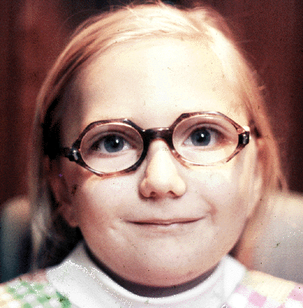
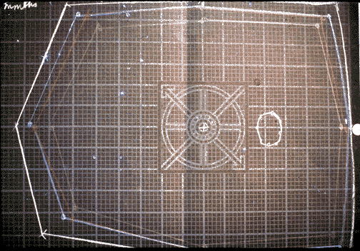
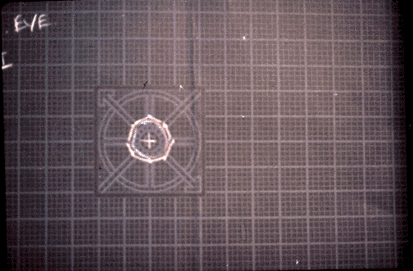
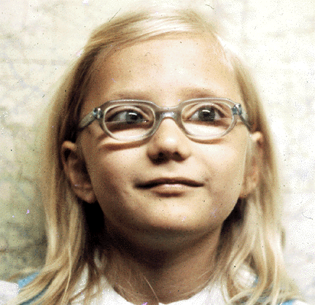
Dr. Gottlieb: Charlie routinely took functional visual fields and before and after photographs and saved these along with the records of many of his more than 3000 syntonics patients when he sold his practice in 1984. He created a narrated slide show with the help of Sarah’s husband, Jim Patton. Below are sample slides from Butts’ slide show showing before and after photos of a young esotrope with before and after visual fields.

Tributes
Dr. Gottlieb: We are very pleased that we were able to present Charlie with CSO’s Lifetime Achievement Award at the 75th CSO anniversary convention in 2007. And we are very happy that he was around to know of our newest award, the Charles Butts Award given in recognition for outstanding service to CSO. It was presented for the first time last year to Dr. Dick O’Connor. Rosemary told me that Charlie was very proud and moved by these tributes.
Many of our colleagues have sent in wonderful stories and statements of respect, appreciation and gratitude for our beloved friend. I would like to have the space to include these here but unfortunately, there isn’t space here. These along with the audio and the transcript from Dr. Ed Kondrot’s “Healthy Vision” 1-hour call-in radio show on March 23, 2014, dedicated to Charlie will be uploaded sometime soon to our website – www.collegeofsyntonicoptometry.com.
When J.O. Jenkins died at age 101 years old, Charlie wrote a loving tribute to honor and remember his beloved teacher and friend. Some of the history in this article I read in that tribute. Charlie said some wonderful things about J.O. that apply as much to Charlie as to J.O. I have taken the liberty of making a few edits and changing the name from J.O. to Charlie.

SYNTONICS — IT IS THE MIRACLE OF OPTOMETRY.
Syntonics was Charlie’s greatest LOVE in optometry. There are not many men or women who would spend their 60’s, 70’s, and 80’s doing this for the fun of it. He had to love and know the feeling of helping mankind and Optometry to have such an effective therapy as we have today.
There is much more that should be said, BUT SO you see, we owe a great debt to this 89 years young person who donated his life to this wonderful field. For those of us that love Syntonics it’s easy to see why Charlie felt as he did.
I hope that now you have a brief history of his important involvement in what and why we are so privileged to practice this therapy of light, you all join me in holding Dr. Charles Butts in your memories and in your hearts for his dedication to and love of Syntonics.
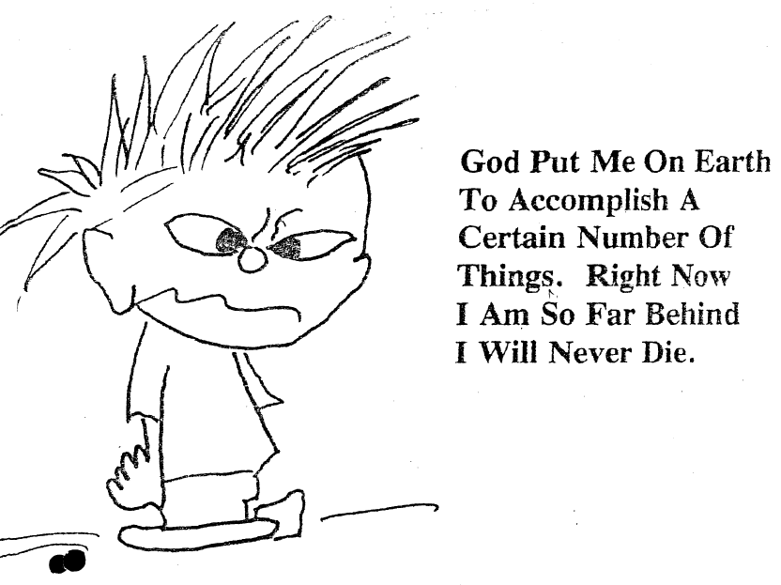
Perhaps without Charlie the practice of Syntonics would not have even survived at all. Yet, here we are bringing a viable alternative for optometrists to be able to bring light and a renewed perception of life into so many lives and on so many levels today.
He strongly believed that “WE [the college] is the wave of the future in therapy for visual problems. We can correct many that are not treatable by any other method.”
Charlie included this cartoon at the end of the CharlieAdvCollection.pdf file. We thought it would be a fitting end to this article because in our hearts, “The Master Syntonist” does live on in our hearts and in our syntonic achievements.
“SYNTONICALLY YOURS, LOVE CHARLIE”

Lifetime Achievement Award
Presented to
Charlie Butts, O.D., Ph.D., FCSO

“The Father of Modern Syntonics”
By the College of Syntonic Optometry
On the Occasion of Our 75th Anniversary Convention
For Over 40 Years You Have Taught and Inspired
Generations of Syntonists. You, More Than Anyone,
Have Kept Syntonics Alive and Vibrant.

We Are Deeply Grateful

May 5, 2007

H. Riley Spitler, DOS, MD, PhD, MS, FSCO
— 1899-1961 —
Formerly Clinician McFadden Sanatorium, Battle Greek, Mich.; Physician-in-charge Crab Orchard Sanatorium, Crab Orchard, Ky.; Past President State Board of Optometry, Ohio; Past First Vice-President American Optometric Association; Accredited teacher of Mechanotherapy and physical therapies since 1925 by Ohio State Medical Board; Past Dean Department of Mechanotherapy Metropolitan College; Dean Central States College of Physiatrics; Fellow American Academy of Optometry; Founder and Dean College of Syntonic Optometry.
Spitler circa 1924. Note the right exotropia.

