**Brain-Based Prescribing for Syntonics**

Presented by Amy Thomas, OD, FCOVD

Financial Disclosure

* Creator of the Brain-Based Optometric Toolbox
* Provider of tinted lenses for trial kits

Syntonics has a long history of “if you want this result, you give this color”

* Works most of the time
* Lots of trial and error
* Takes a while to learn – constantly tied to the manual
* Do not know if it will work until the patient returns from treatment
* If it doesn’t work as planned, what next?

Daniel Amen, PhD

* (About Psychiatry – But applies to Neuro-optometry)
* “We are one of the few professions that does not measure the organ that we treat”
* “We hear a symptom - we give a cookbook treatment (ie: Ritalin for ADD)”

The Problem

* Symptoms are just the body’s way of communicating a problem not the problem itself
  + What is the source problem?
  + Example: ADD – 7 types – each involve different brain regions

The Answer

* 2-minute technique
* Can be done in any quiet setting
* Shows best brain region to treat
* Can show best syntonics, lenses, and therapy for the brain at that moment – “it’s like communicating directly with the brain and asking it what it needs”

Goals for Today

* Show the how this process developed
* Introduce you to the brain and its team
* Show you which colors approach which team members best
* Show you some patterns on why certain colors help certain imbalances
* Provide a platform that is easy to teach and perform so more optometrists can use it
* Open up the floor for other ideas and suggestions

Spitler Experiments – 1920-30’s

* Rabbits were placed in separate cages and exposed to different wavelengths of light (colors)
* Amazing results showed endocrine changes – through hypothalamic pituitary axis (HPA) - endocrine

Syntonic Blue Book

* Alpha as High Sensory Stimulant

Syntonic Blue Book

* Delta as Motor Stimulant
* Theta as Intense Motor Stimulant

Motor Vs. Sensory

* Motor cortex is in Frontal Lobe
* Sensory cortex is in Parietal Lobe
* BCIA – Neurofeedback (Biofeedback Certification International Alliance)

Asthenic Vs. Pyknic

* Asthenic – head dominates over body
* Pyknic – body dominates over head
* Upper brain – head dominates over body
* Lower brain – body dominates over head
* Asthenic = upsilon and delta = Upper brain
* 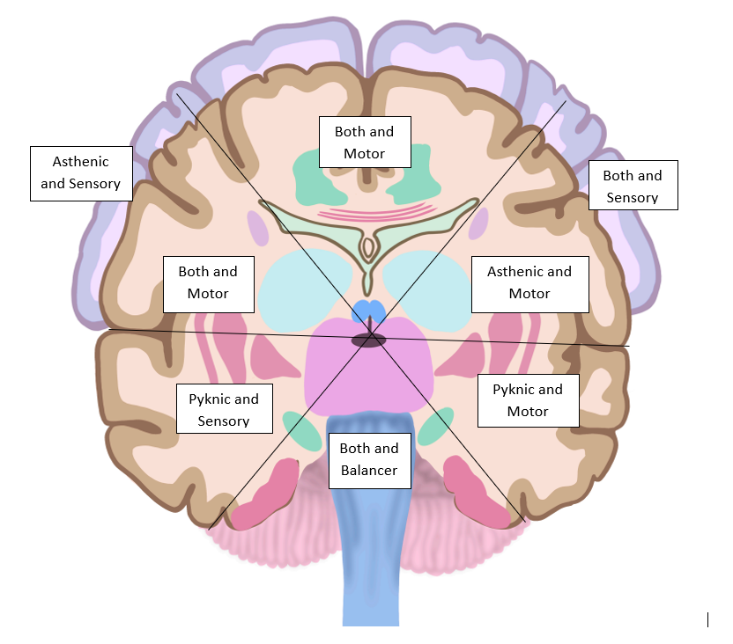Pyknic = pi and theta = Lower brain
* Syntonic Blue Book
* Syntonic Principle – Spitler
* Syntonics 101 and 201

Rough Draft

Current Proposal  
of Color   
Map

Introduction to the Brain

* The brain as a company
* Many different parts
  + Different functions/roles
  + Different “personalities”
  + Different “moods”
  + Different “maturity levels”

Different “Personalities”

Right Brain Focuses on Flighting

* + More peaceful
  + Slower
  + More create/grow
  + More withdraw

Different “Personalities”

Left Brain Focuses on Fighting

* + More Assertive
  + Quicker
  + More Tear Down/Destroy
  + More Approach

Different “Personalities”

Top Brain Focuses on Freezing

* Detach from emotions/drama
* Decrease movement to avoid detection

Different “Personalities”

Bottom Brain Focuses on Fawning

* Increases action and movement
* Increases pleasing of aggressor
* Increases awareness of others’ emotions and motives

Different “Moods”

Right side tendencies

* + On a Good Day
    - Calm, Big picture, connect patterns, Understand root cause
    - Heal, rest, detox, grow, digest, sleep
  + On a Bad Day
    - Run, hide, withdraw, give up, whine
    - Deny that “bad guys” exist – allow in, always sick

Different “Moods”

Left side tendencies

* + On a Good Day
    - Enjoy, quick with language, logic, and details, approach, brave
    - Fight infections, prevents infections, energizes
  + On a Bad Day
    - Attack, yell, frustrate, perseverate, ADHD, addicted (needs a fix)

Different “Moods”

Top Brain tendencies

* On a Good Day
  + Chilled out
  + Anti-drama
  + Less “whining”
* On a Bad Day
  + Detached
  + Inactive
  + Think Pot Head

Bottom Brain “Moods”

Bottom Brain tendencies

* On a Good Day
  + Active
  + Productive
* On a Bad Day
  + Dramatic
  + Emotional
  + Busy work

Different Maturity Levels

Immature

* + Not developed
  + More rambunctious when activated

Well-developed

* + “Cultured”
  + Able to handle extra duties when activated

Senile

* + Worn out, not well-nourished
  + More overwhelmed when activated

Colors and the Brain

Different areas of the brain receive wavelengths more easily and act as transmitters to the team

* Melillo Neurodevelopmental Courses

Different Cells Respond to Different Frequencies

* Similar to thermostats
  + When temperature drops to certain level, signals to start heater
  + Activate DNA to produce signal
  + Transmits signal to preprogrammed areas (networks)
  + Voltage is Healing - Tennant

Brodmann’s Areas

* German anatomist Korbinian Brodmann (1909)
* Based on cell type (cytoarchitecture)
* 52 areas in humans
* Biofeedback Certification International Alliance (BCIA) Courses

Left Parietal - Alpha

Benefits:

* + Helps you set boundaries (understand benefit vs. effort)
  + Enjoy the moment
  + Seek fun
  + Start projects

When fully cooked:

* + Look for next “fix”
  + Dazed, twitchy

Left Frontal - Delta

Benefits

* + More motivation, less procrastination
  + Ability to do multiple things at once
  + Feel more in control, less scattered
  + More energetic, less lethargic
  + Can help ADD symptoms (improve focused attention)

When fully cooked:

* + Twitchy, irritable, snappy

Left Temporal - Theta

Benefits:

* + Joy, enthusiasm
  + Sense of Humor

When fully cooked:

* + Desire to become a hermit far from other humans (esp negative humans)

Lower Brain   
(Includes Cerebellum) - Mu

* Stimulates lower brain
* Benefits:
  + Improves pituitary balance and glandular support (works like oxytocin – think “squeeze or drain”)
  + Improves sense of well-being, that someone “has your back” (also like oxytocin)
* Common complaints if too much:
  + May become detached and ignore people around them

Right Temporal - Pi

* Benefits
  + Improve balance
  + Improve vertical deviations in eyes
  + Decrease misophonia (possibly tinnitus)
  + Decrease overwhelm in short-term memory
  + Decrease agitation/frustration
  + Improve ability to read social cues
  + Improve spiritual connection
* When fully cooked
  + Dizzy
  + Problems with short-term memory

Right Frontal - Omega

* Benefits:
  + Helps concentration (decrease “squirrels”)
  + Improves sense of calm
  + Improves ability to create – essays, phone skills
  + Improves ability to get to the point
  + Helps decrease/relax muscle spasms
* When fully cooked:
  + May feel like something is pressing them down
  + May be more lethargic

Right Parietal - Upsilon

* Benefits
  + Improve ability to understand where you are
  + Improve proprioception
  + Improve self-awareness
  + Calm the brain
  + Improve volume control for sensory info
* When fully cooked
  + Spacey – problems remembering details
  + Scattered – especially timewise

Upper Brain – Neurasthenic

* Benefits:
  + Takes the “heat” off of the lower brain – shuts down emotional charge
  + “Scooby Snack” Glasses – less “I can’t”, more “I can”
* Common complaints if too much: difficulty finding energy (if originally learned to increase anxiety or frustration to increase control of eyes/body)
* When fully cooked:
  + May feel detached, apathetic

The Path to Discovery….

* Jens Blauert’s Psychophysics of Human Sound Localization
  + Great for explaining the why’s of sound localization
* [Charles Wheatstone](https://en.wikipedia.org/wiki/Charles_Wheatstone) (1802–1875) did work on optics and color mixing, and also explored hearing
  + Starting to mix vision and hearing concepts
* [Ernst Heinrich Weber](https://en.wikipedia.org/wiki/Ernst_Heinrich_Weber) (1795–1878) and [August Seebeck](https://en.wikipedia.org/wiki/August_Seebeck) (1805–1849) and [William Charles Wells](https://en.wikipedia.org/wiki/William_Charles_Wells) also attempted to compare and contrast what would become known as binaural hearing with the principles of binocular integration
  + Great but where are the protocols?
* Dr. Deborah Zelinsky’s Z-Bell Method
  + Able to localize retinal pathways
  + Not currently offered as mainstream training
* Functional Neurologists
  + Have hundreds of motor and sensory tests
  + Help localize problem pathways in brain
  + Too specific for my purposes
  + Useful as back-up though
* Dr. Mark Ellis’ Tonotopic Mapping taught by Dr. Jonathan Arkin (Carrick Institute)
  + The quick protocols!

Useful Connections in the Brain

Thalamus as Central Integrator

* Sound location data becomes fully integrated by the inferior colliculus then thalamus
* Visual location data becomes fully integrated by the superior colliculus then thalamus

Vision and Auditory are Yoked

* Can map balance and comfort of vision through auditory mapping
* Explanation #1
  + To hear and see well, a person must be oriented toward a target
  + Visual misalignments cause auditory misalignments
    - Helped with lenses, colors, therapies (and smells, and sounds, and vibration, etc.)
* Explanation #2
  + The brain is bombarded by light and sound throughout the day
  + There are tender areas of the brain that “distract” a person from orienting themselves toward the target
  + Shifting stimulus away from those tender areas helps improve basic function

Determining Best Brain Region

* Blind Snap Test
  + Takes less than a few minutes
  + Helps find area of the brain that needs stimulation
  + Helps discover other imbalances that could be occurring with emotions and organs

Blind Snap Test Using Posture

* Shifting posture shifts eyes, ears, attention

Other Methods

* Vibration
  + On contralateral body
* Eye gaze
  + Patient to look at opposite field
* Testing with different colors
  + Blue – right
  + Yellow – left
  + Purple – superior
  + Green - inferior
* Cognitive multitasking
  + Activate right = space, tone
    - “Doe a Deer”
  + Activate left = time
    - Count to rhythm
  + Etc.

Procedure

* Find the area that needs the most stimulation
  + Best results with testing
* Find the color on the map that corresponds to that area
  + For example – top right – try omega or upsilon
* If testing is not completely better, add another color
  + Think about the function/network that is challenged (more to follow)

Miracle Worker – Mu-Upsilon

* Stimulates lower right brain – Right Parietal to Lower Brain
* Benefits:
  + Anti-inflammatory
  + Good for migraines, sinus problems, stuffy head

Miracle Worker – Mu-Delta

* Connects lower brain with left frontal
* Benefits:
  + Detoxing (squeezes toxins out of brain and body)
* Common complaints if too much:
  + If not detoxing well, may notice nausea and/or fatigue
  + Patient needs to increase detox and ability to poop – Ionic footbath, Epsom salt baths, Magnesium, Vitamin C
  + Known as the “can opener” – so may have extra emotions (tends toward irritability, frustration, anger bc left brain stim)
* When fully cooked:
  + A hint of ornery

Miracle Worker – Alpha-Delta

* Connects left parietal and left frontal
* Benefits:
  + Improves vascular support (pressure modulation)
  + Improves energy levels
  + Improves the ability to use the optic “channels”
  + Helps eyes diverge (sympathetic – look for “tiger”)
* Common complaints if too much:
  + Increased agitation, decrease parasympathetic function

(sleep, digest, rest, heal, detox)

* When fully cooked:
  + A hint of snippy

Miracle Worker – Alpha-Omega

* Connects left parietal and right frontal
* Benefits:
  + Improved control (impulse control, emotion control)
  + Improved ability to shift gears
  + Better connection between right and left brain functions through top of brain (thinker) instead of bottom (feeler)
* Common complaints if too much:
  + Some squirrelliness – especially in kids
* When fully cooked:
  + A hint of restlessness
* NOTE: Procedure for improving peripheral attention
* NOTE: Fronto-parietal network and number processing/ calculations – hidden bonus

Miracle Worker – Pi-Omega

* Connects right temporal and right frontal
* Benefits:
  + Improves balance between the vestibular apparati in right and left brain
  + Improves overwhelm in left temporal / left frontal regions (seen as problems with time management, rhythm, memory)
* Common complaints if too much: Will feel dizzy or off because it “rotates the world”
* When fully cooked:
  + A hint of “teenage brain”
  + – refuses to do therapy

Miracle Worker – Upsilon-Omega

* Connects right frontal and right parietal
* Benefits: calm focus, ability to multi-task
* Common Complaints if too much: feels slower
* When cooked: lethargy, less motivation

Other - Alpha-Upsilon

* Connects left and right parietal
* Benefits: takes “heat” off of Hypothalamic-Pituitary (HPA) axis, calms endocrine
* Common complaints if too much: jump starts hormone action – sudden change to menses, hot flashes, mood changes
* When cooked: less impulse control, less emotional regulation

Functional Networks – 6 Big Ones

Functional Networks – Rhyming and Rhythm

EEG Results

**Mu**

**Mu-Delta**

EEG Results

Example Case #1 - Intro

* 34yof
* CC: Studying for Masters Degree – has difficulty with reading – skips words, problems concentrating, problems remembering, problems sitting still, mind races
* Exam remarkable for exo at near, pursuits jump into right gaze, saccades undershoot to left, hallway walk showed less movement of left arm, toes flared, color field showed restriction in blue
* Blind snap test showed that best brain region to stimulate is upper right, worst is lower left

Example Case #1 - Discussion

* Snap test with Omega – all on target except lower left target
* Snap test with Upsilon – all on target except upper left target
* Upsilon-Omega – all targets on
* Plan: Upsilon-omega 10min/day x 20 days; RTC 1 month

Example Case #2 - Intro

* 10yof
* Very creative, struggles to pay attention with reading and math, rereads words, struggles to say the correct words when speaking, weepy, history of mold in home 2 years ago
* Exam remarkable for eso at near, pursuits jump into lower left gaze, saccades undershoot to upper right, color field shows restriction in green OU
* Blind snap test shows best brain region to stimulate is lower left brain, worst is upper right brain

Example Case #2 - Discussion

* Snap test with mu – all on target except upper and lower targets
* Snap test with theta – only upper target on, all others off
* Snap test with delta – all on but upper right
* Snap test with mu-delta – all on target
* Plan: Mu-delta 10min/day x 20; Initiate detox protocol (increase Vitamin D, consider binders – activated charcoal or clay 1g/d 2h away from other meds/supplements, consider ionic footbath every 3 days); RTC one month

Example Case #3 - Intro

* 60yom
* Pressure headaches in eyes and top of head, very irritable, avoids reading
* Exam remarkable for near point of convergence out to 40cm, eyes hurt with tracking so refused pursuits and saccades, refused color fields
* Blind Snap Test showed best brain region to stimulate is lower right, worst is upper left

Example Case #3 - Discussion

* Snap test with Pi – all areas off except upper left
* Snap test with Mu – all areas on except lower center and lower right
* Snap test with Mu-Omega – worse – only on target for upper central
* Snap test with Mu-Upsilon – on target for all
* Plan: Mu-Upsilon 10min/day x 20 days; Recommend hydrating; RTC one month

Contact Me…..

* For Full Handouts or Questions:
  + Email at [bbotoolbox@gmail.com](mailto:bbotoolbox@gmail.com)

Extras

Included in case they come up as questions

Auditory Maps

* Over 6 different maps for sound localization in the brain
  + Most similar to occipital lobe for vision is Heschl Gyrus

References

* [www.csovision.org](http://www.csovision.org/)
* [www.carrickinstitute.com](http://www.carrickinstitute.com/)
* [www.iafnr.org](http://www.iafnr.org/)
* [www.mindeye.org](http://www.mindeye.org/)
* [www.denisehadden.com](http://www.denisehadden.com/)
* [www.amenuniversity.com](http://www.amenuniversity.com/)
* [www.wavimed.com](http://www.wavimed.com/)
* [www.bcia.org](http://www.bcia.org/)
* [www.bbotoolbox.com](http://www.bbotoolbox.com/)
* Syntonic Principle: Harry Riley Spitler
* Principles of Light and Color by Edwin Babbitt
* Voltage is Healing by Jerry Tennant
* Functional connectivity of brain networks with three monochromatic wavelengths: a pilot study using resting-state functional magnetic resonance imaging. Argilés, M., Sunyer-Grau, B., Arteche-Fernandez, S. *et al. Sci Rep* 12, 16197 (2022).