Case Report: Resolution of Diplopia in a 38-Year-Old Female Patient Following Syntonic Therapy
Introduction: In July 2022, a 38-year-old female patient presented at the Rotary Eye Institute, Navsari, with a chief complaint of diplopia. The patient reported experiencing diplopia since 2021, with no prior history of this condition. Her childhood was with high myopia, leading to lens extraction in both eyes at the age of 10. At 30 years of age, she underwent vitrectomy with belt buckling for a rhegmatogenous retinal detachment in her left eye. The patient had no history of brain injury or systemic illnesses. During the COVID-19 lockdown in India in 2020, she reported prolonged use of digital devices for hours.
Clinical Evaluation: Initial Binocular Vision Evaluation
- Corrected Vision: RE: 6/6, LE: 6/6
- Previous Glass Prescription:
  - Right Eye: -1.00/-2.25 x 20 with 4 Prism Base out
  - Left Eye: -0.50/-1.75 x 170 with 4 Prism Base out
- Both Eyes Near Add: +2.00 Dsph
- Refraction:
  - Right Eye: -2.00 x 170
  - Left Eye: -2.00 x 175
- Both Eyes Near Add: +2.00 Dsph
- Slitlamp: Both Eyes Aphakia
- Pupil:
  - Right Eye: Small Miotic Pupil
  - Left Eye: Pupil Irregular
- Intraocular Pressure (IOP) on Non-Contact Tonometer:
  - RE: 20 mm of Hg
  - LE: 18 mm of Hg
- Extraocular Muscle (EOM) Evaluation: Mild restriction on dextroversion with jerk present, but full gaze movement in other directions.
- Cover Test: Right Eye - Esotropia (Greater at distance than near)
- Prism Bar Cover Test: D: 20 Prism Base out, N: 8 Prism Base out
- Worth Four Dot Test: Diplopia present at all distances with 5 dots seen
- Stereoacuity: Absent
- Pursuit Eye Movement (NSUCO Test): Ability/Accuracy/Head & Eye movement - 2/2/3
- Saccadic Eye Movement (NSUCO Test): Ability/Accuracy/Head & Eye movement - 3/2/3

Diagnosis: The patient was diagnosed with right eye esotropia leading to diplopia.
Treatment: Vision therapy was recommended as the initial treatment. Binasal glasses were prescribed, and home vision therapy, along with three in-office therapy sessions per week, were initiated. Due to the unavailability of syntonics, functional visual field testing was not conducted initially.
Treatment Protocol:
- In-office Therapy: During the initial six months, vision therapy was continued, focusing on activities related to crowding, saccades, and pursuit, addressing peripheral vision deficits.
- Syntonic Therapy (Started in April 2023): Syntonic therapy was introduced using the FCF Tester, employing Alpha delta and Mu Delta filters for 20 minutes three days a week. After 20 sessions, improvements were observed. A total of 30 sessions were conducted.

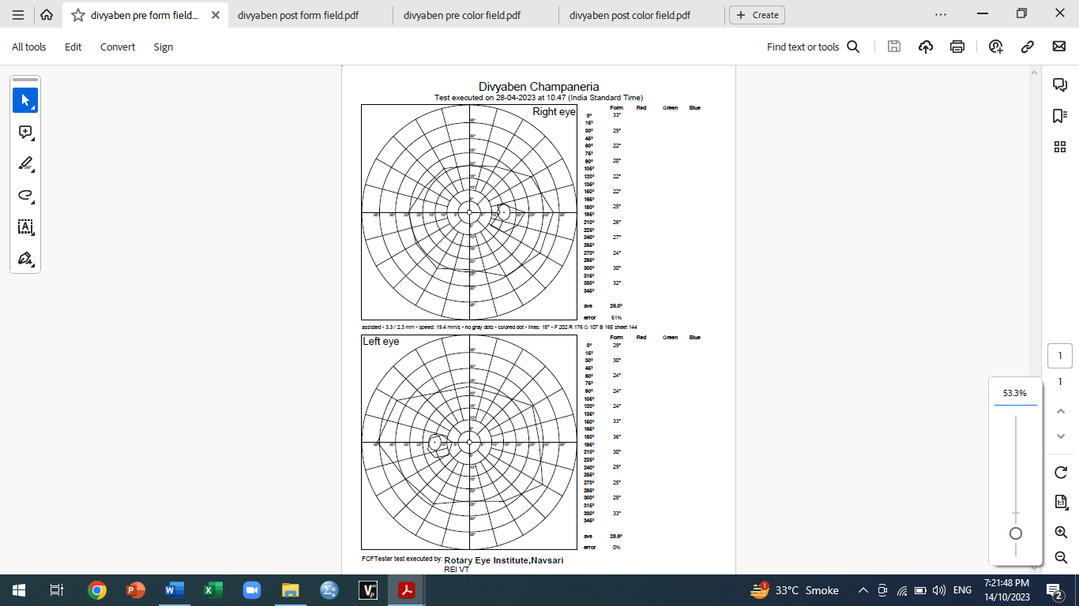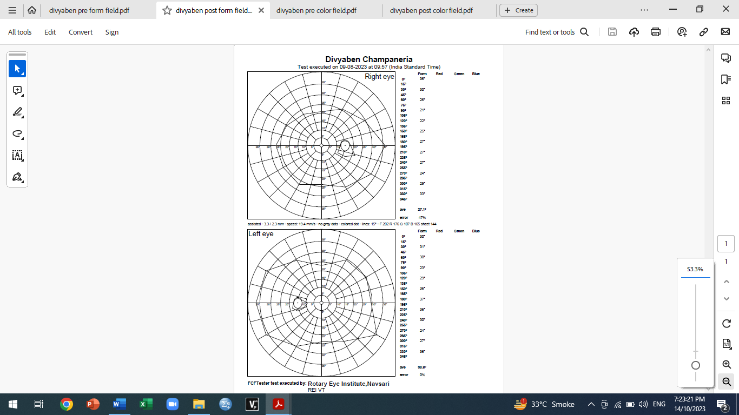

Pre-Syntonic Form Field After 20 Session Post Syntonic Form Field

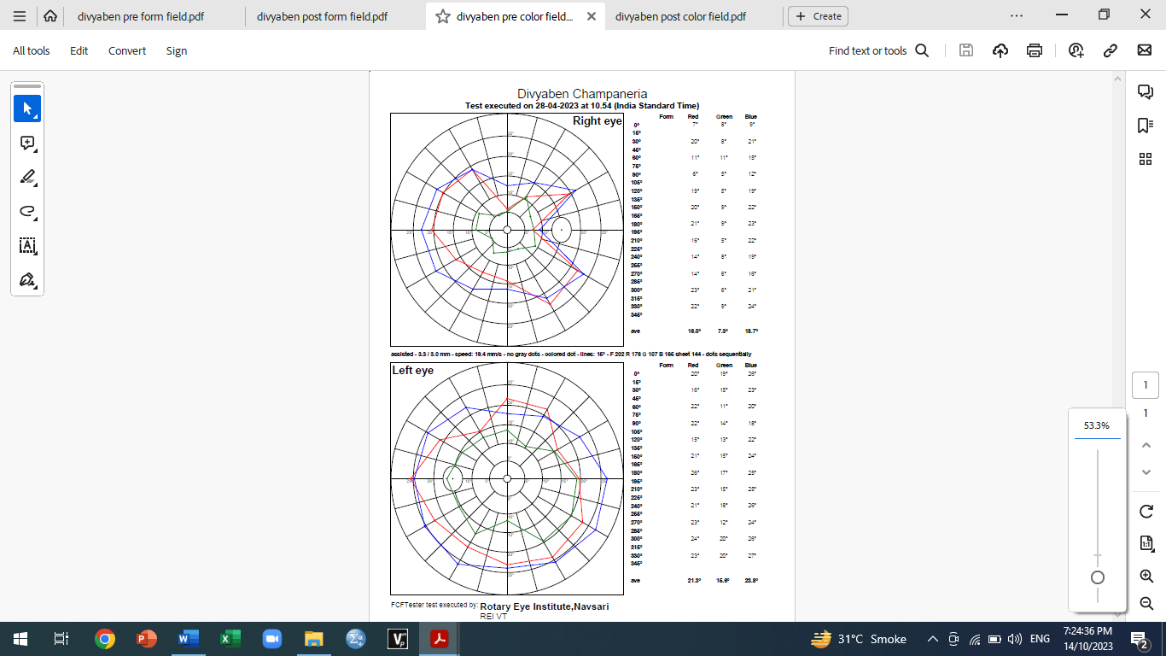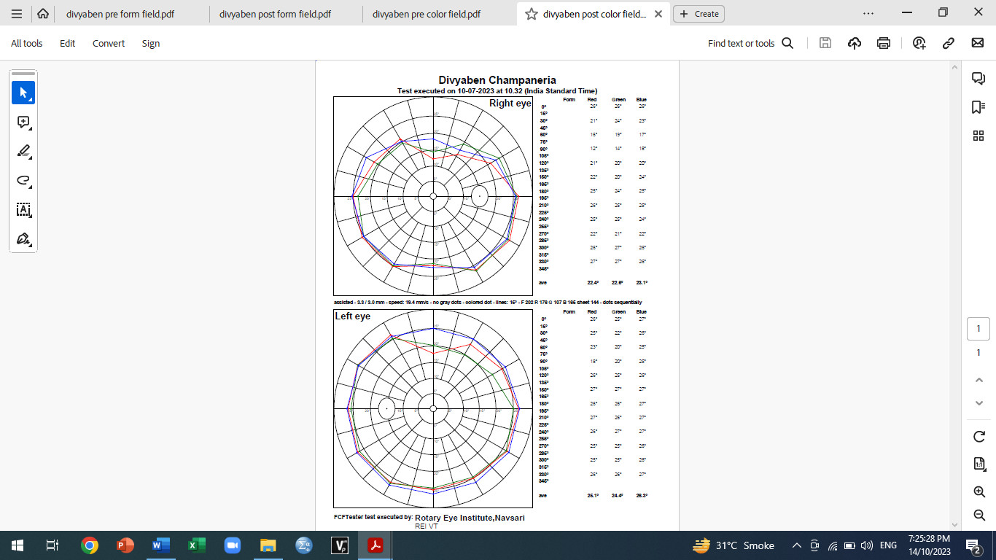

Pre-Syntonic Color Field After 20 Session Post syntonic Color Field

Post-Syntonic Evaluation:
- Corrected Vision: RE: 6/6, LE: 6/6
- EOM: Ocular Movement Normal in all directions
- Cover Test:
  - Near: Orthophoria
  - Distance: Right Eye Esotropia (Decreased)
- Prism Bar Cover Test:
  - Distance: 10 Prism Base out
  - Near: Orthophoria
- Worth Four Dot Test:
  - Distance: Diplopia at 3 meters (Single vision with 2 prism base out in both eyes)
  - Near: Normal
- Stereoacuity: 100 Seconds of Arc
- Pursuit Eye Movement (NSUCO Test): Ability/Accuracy/Head & Eye movement - 5/5/5
- Saccadic Eye Movement (NSUCO Test): Ability/Accuracy/Head & Eye movement - 5/5/5
Outcome: Following syntonic therapy, the patient reported comfortable vision at all distances, and she could drive comfortably. She occasionally wore prisms while driving on highways. Diplopia was no longer a concern.

Dr.Nirav Mehta
M.optom, Ph.D, FAAO, FIACLE, FASCO(DO), PG Dip in Biostatistics
Principal
Hari Jyot College of Optometry
Rotary Eye Institute, Navsari-396445
Gujarat, India

