
Amy Thomas, OD, FOVDR

BILATERAL PAPER CRINKLE AND Z-AXIS STICK IN STRAW WITH S-STIMULANT AND D-DEPRESSANT
PURPOSE: To better understand the role that vision and hearing play in estimating distances, coordinating and equalizing the eye-hand connections along the Z-axis, and improving any mismatches in aim along the Z-axis.
EQUIPMENT: Patient, helper, S-Stimulant and D-Depressant Syntonic glasses, 1 straw, 2 sticks, a few sheets of paper (8 1/2 in. X 11 in), a distant visual target.
ACTIVITY:
LEVEL 1:
- 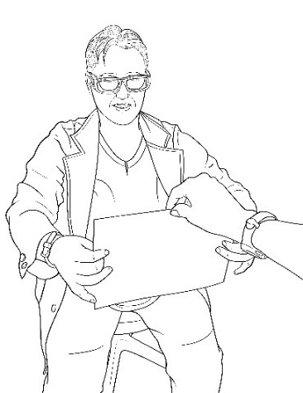Wear the S-STIMULANT SYNTONICS then repeat activity with D-DEPRESSANT SYNTONICS.
- The helper will hold a sheet of paper below the patient’s eye level.
- With both hands the patient will crinkle each side of the paper while looking straight ahead and acknowledging the paper peripherally, how the crinkle feels and the sound it makes.
- The helper will now move the paper above the patient’s eye level.
- With both hands the patient will crinkle each side of the paper while looking straight ahead and acknowledging the paper peripherally, how the crinkle feels and the sound it makes.
- 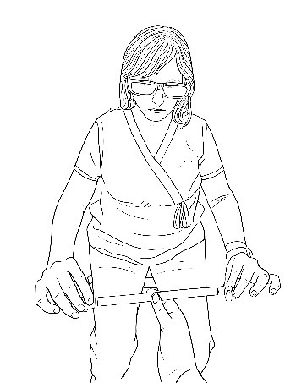The patient will now twist at the waist while looking ahead and the helper will move the paper to the left and afterwards to the right of the patient at eye level.
- With both hands the patient will crinkle each side of the paper while looking straight ahead and acknowledging the paper peripherally, how the crinkle feels and the sound it makes.
LEVEL 2:
- Wear the S-STIMULANT SYNTONICS then repeat activity with D-DEPRESSANT SYNTONICS.
- The helper will hold a straw horizontally about 18 inches away from your face at eye level.
- 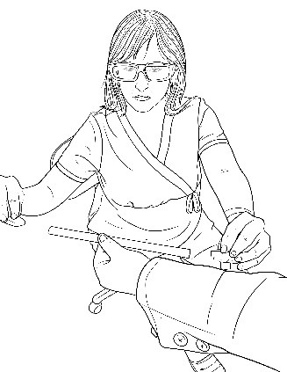Patient will hold one stick in each hand attempt to get them into the 2 ends of the straw at the same time , then remove them for the next step.
- The helper will then move the straw to the right of the patient at eye level.
- Patient will then twist at the waist and attempt to get each stick into the 2 ends of the straw at the same time , then remove them for the next step.
- The helper will then move the straw to the left of the patient at eye level.
- Patient will then twist at the waist and attempt to get each stick into the 2 ends of the straw at the same time , then remove them for the next step.
WHAT TO LOOK FOR:
1. If the patient is off target repeatedly and does not seem to be improving, the patient is to stop their hand where they think the target it, the helper is to lightly tap the hand, then the patient is to quickly look at where their hand is located.
2. The syntonics will change the location where the patient perceives the target (S-Stimulant should bring the target closer, D-Depressant should push the target farther). If the patient is on target easily, check for peeking, reach faster or add a metronome.
3. If the patient continues to struggle with aim, add a white light to the target and dim the room lights.

