
Amy Thomas, OD, FOVDR

FINGER LIGHT – BODY MAPPING WITH ALPHA-DELTA
PURPOSE: To harness alpha-delta’s ability help the patient discriminate different body parts more easily and automatically. Since the hands share the same areas of the brain (homologous columns), teaching the hands will indirectly teach the eyes.
EQUIPMENT: Patient, Alpha Delta syntonic glasses, 2 white lighted finger lights, large mirror.
ACTIVITY:
- Wear the Alpha Delta syntonic glasses before you begin.
- Place a white finger light on your pointer finger and another white finger light on your thumb.
- Hold up the mirror across from the patient’s face and have them try and touch/pinch different parts of their face (Ex. Nose, cheek, chin, ears, forehead, hair).
- Repeat touching the face while looking at the mirror if they need help to identify the correct location.
- Use the mirror to touch/pinch different body parts (Ex. Neck, shoulders, arms, elbow, knees, shins, feet).
- Repeat touching the body while looking at the mirror if they need help to identify the correct location.
WHAT TO LOOK FOR:
- 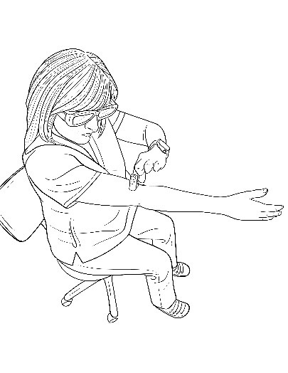 If the patient struggles to touch the correct body parts in the mirror, back up to no mirror use then return to using the mirror when they become more accurate.
