
Amy Thomas, OD, FOVDR
POI BALL EYE HAND COORDINATION WITH MU-DELTA
PURPOSE:
To improve the eyes’ ability to accurately track a lighted object by stimulating and harnessing the cerebellum. It also improves coordination between different body parts/movements. Used when patient is struggling to coordinate movements of different body parts.
EQUIPMENT:
Patient, 2 lighted Poi Balls, Mu Delta syntonic glasses.
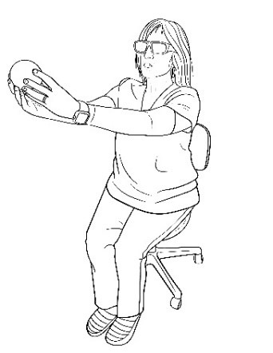ACTIVITY:
- Wear Mu Delta syntonic glasses before you begin.
- Hold 1 Poi Ball with Both hands at eye level about 15 inches away from nose.
- Horizontal Circle (Carousel)
- Move Poi ball in a circle the width of your shoulders, no closer than your elbows or farther than your arm’s reach.
- 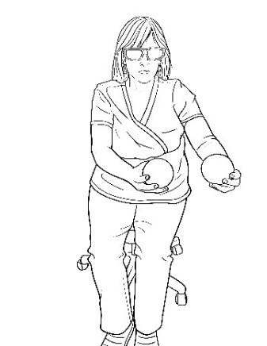First, keep your eyes on a point in the distance and without moving your head, rotate the lighted Poi ball clockwise for 30 seconds for each of the following so that the light is presented to your eyes in all possible fields:
- Below eye level (chest level).
- At eye level.
- Above eye level (even with top of head).
- Look for asymmetries in body movements and address them before step 5.

- 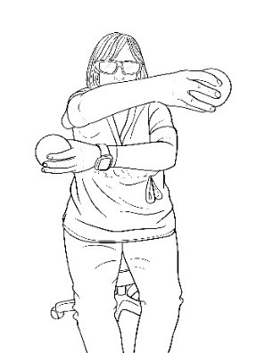Second, move Poi ball in a circle while keeping your eyes on the ball and without moving your head for 30 seconds for each of the above steps.
- Repeat with 2 lighted Poi Balls, keep about 1-2 inches between the two Poi Balls horizontally and move in the same circles as above.
- Extra high level: Repeat the above but move the balls in opposite directions (will look like doing a breaststroke/starfish move).

- Vertical Circle (Ferris Wheel):
- Move Poi ball in a vertical circle whose highest point is just above your head and lowest point is chest level, no closer than your elbows or farther than your arm’s reach.
- 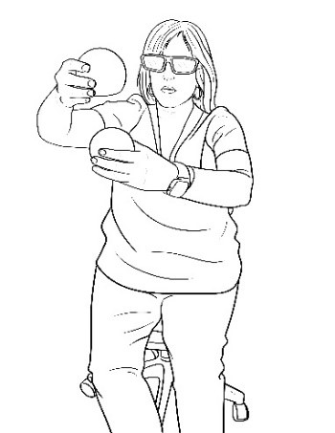First, keep your eyes on a point in the distance and without moving your head, rotate the lighted Poi ball in a vertical circle with both hands on the same ball starting at the nose and going away from face and then in the opposite direction:
- Look for asymmetries in body movements and address them before step 5.
- Second, move Poi ball in a circle while keeping your eyes on the ball and without moving your head for 30 seconds for each of the above steps.
- Now hold 1 Poi Ball in each hand having them touch and stay together while moving in a vertical circle starting at the nose and going away from face and then in the opposite direction like a Ferris wheel for 5 rotations. Track the Poi balls with your eyes.
- Now hold 1 Poi Ball in each hand keeping them about 1-2 inches apart while moving in a vertical circle starting at the nose and going away from face and then in the opposite direction like a Ferris wheel for 5 rotations.
- Now hold 1 Poi Ball in each hand keeping them about 1-2 inches apart while moving in a vertical circle starting at the nose with 1 Poi ball going away from face and the other Poi ball going toward the face opposite directions of each other, then reverse the Poi balls directions like a Ferris wheel for 5 rotations.
- Extra high level: Repeat the above but move the balls in opposite directions.
WHAT TO LOOK FOR:
1. If the jump remains, have the patient lay on their back and track the poi balls as before.
2. If the jump remains, consider adding red/infrared light therapy to the patient’s cerebellum (lower back skull ) for 5-10 minutes while doing tracking activities.

