
Amy Thomas, OD, FOVDR

POI BALL SACCADES WITH DELTA-OMEGA
PURPOSE: To improve function of the frontal lobes (specifically the frontal eye fields) to allow for more impulse control, ability to shift gears, and more accurate voluntary eye saccades.
EQUIPMENT: Patient, 2 lighted Poi Balls, Delta Omega syntonic glasses, mirror or central target.
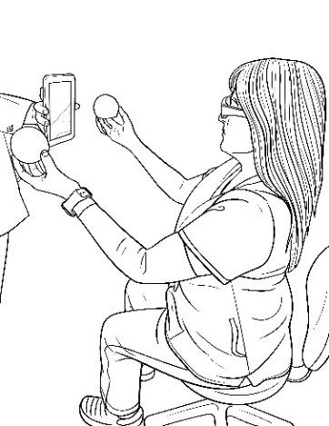
ACTIVITY:
- Wear the Delta Omega syntonic glasses before you begin.
- Hold one Poi Ball in each hand at eye level and even with your shoulders, place a mirror between the 2 balls.
- Cast your eyes from the Poi ball in your right hand to the mirror and then to the Poi ball in your left hand. Continue jumping back and forth for about 30 seconds.
- Now hold both Poi balls above eye level. Keep the mirror in place.
- 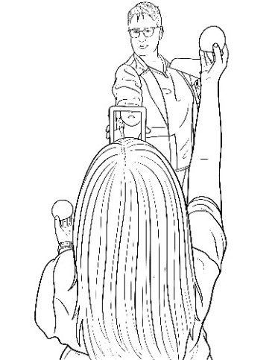Cast your eyes from the Poi ball in your right hand to the mirror and then over to the Poi ball in your left hand. Continue jumping back and forth for about 1 minute.
- Now hold both Poi balls below eye level. Keep the mirror in place.
- Cast your eyes from the Poi ball in your right hand to the mirror and then over to the Poi ball in your left hand. Continue jumping back and forth for about 1 minute.
- Now hold one Poi ball below eye level and one above eye level, but the mirror will stay in place.
- Cast your eyes from the Poi ball in your right hand to the mirror and then over to the Poi ball in your left hand. Continue jumping back and forth for about 1 minute.
- Now hold one Poi ball above eye level and one below eye level opposite of step #8, but the mirror will stay in place.
- Cast your eyes from the Poi ball in your right hand to the mirror and then over to the Poi ball in your left hand. Continue jumping back and forth for about 1 minute.
WHAT TO LOOK FOR:
1. Add a metronome or music with a beat when this becomes too easy.
2. If the patient sees double, have them alternately patch eyes.

