
Amy Thomas, O.D., FOVDR

POI BALL VESTIBULAR-OCULAR INTEGRATION FOR VERTICAL DEVIATIONS WITH PI-OMEGA OR DELTA-THETA
PURPOSE: To decrease mismatch in perception of the vertical plane between the eyes. Improve coordination of eyes and hands while moving in the Z-axis.
EQUIPMENT: Patient, 2 lighted Poi Balls, Pi Omega or Delta Theta syntonic glasses.
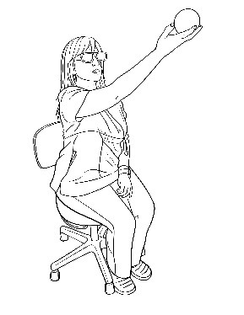ACTIVITY:
Ferris Wheel:
- Wear Pi Omega or Delta Theta syntonic glasses before you begin.
- Use Right hand to move a Poi ball in a vertical circle starting at the nose and going away from face and then in the opposite direction like a Ferris wheel for 5 rotations. Track the Poi ball with your eyes.
- Repeat with Left hand.
- Next, hold the Poi ball stationery at eye level and at arm’s reach. Nod the head up and down with both eyes looking at the ball. Do this for 30 seconds while holding with your right hand. Repeat with your left hand.
WHAT TO LOOK FOR:
- If it is not obvious which eye is hyper, have the patient wear pi-omega and stand on each leg separately. Repeat with delta-theta. Use the color that brings the best balance.
2. If there is a continuous “hitch” in the rotation of either ball, have the helper do joint centration of the wrist, elbow, and shoulder on both sides of the patient’s body.
3. If there continues to be a “hitch”, have the helper hold their hand on the patient’s wrist, elbow, or shoulder on the most affected side.
4. Fun Fact: Nodding the head recruits the inner ear on each side to help the same-side eye move more easily.
5. Fun Fact 2: Holding the visual target in the hand helps “tell the eye where to go” because the controls for the hand and eye are neighbors in the brain and are designed to help each other.

